

**Tribhuvan University**

**Faculty of Humanities and Social Sciences**

**Project Report**

**On**

**Futsal Management System**

**Submitted to**

Department of Computer Application

Everest Innovative College

***In partial fulfillment of the requirements for the Bachelors in Computer***

***Application***

**Submitted by**

ROHAN SHRESTHA

6th Semester, 2019 Batch

Reg. no: 6-2-713-21-2019

July 2023

Under the Supervision of

**Basanta Chapagain**



**Tribhuvan University**

**Faculty of Humanities and Social Sciences**

**Everest Innovative College**

Solteemode, Kathmandu

Bachelor in Computer Applications (BCA)

# SUPERVISOR’S RECOMMENDATION

I hereby recommend that this project prepared under my supervision by **Rohan Shrestha** entitled **“Futsal Management System”** in the Partial Fulfillment of requirement for the degree of Bachelor in Computer Application is recommended for that final evaluation.

Basanta Chapagain

Project Supervisor

BCA Department

Everest Innovative College



**Tribhuvan University**

**Faculty of Humanities and Social Sciences**

**Everest Innovative College**

Solteemode, Kathmandu

Bachelor in Computer Applications (BCA)

# LETTER OF APPROVAL

This certify that this project is prepared by **Rohan Shrestha** entitled **“Futsal Management System”** in the Partial Fulfillment of requirement for the degree of Bachelor in Computer Application has been evaluated. In our opinion it is satisfactory in the scope and quality as a project for the required degree.

Kishor Kafle

Program Coordinator

Everest Innovative College

Solteemode, Kathmandu

Basanta Chapagain Supervisor

BCA Department

Everest Innovative College

Basanta Chapagain  
Internal Examiner

External Examiner

# ABSTRACT

Futsal Management System is a web-based application developed to transform the management and booking process of futsal courts, providing a comprehensive platform for both futsal business owners and customers. Futsal, a popular indoor variant of soccer played on a smaller field, has gained global recognition, and this project specifically aims to enhance the futsal experience in the Kathmandu area. The primary objective of this project is to create a user-friendly platform that seamlessly connects futsal business owners with customers, simplifying the online court booking process. Through the web application, customers are empowered with a wide selection of futsal courts conveniently located within the Kathmandu area, allowing them to easily make reservations and secure their preferred time slots. Futsal business owners benefit from an intuitive interface that enables efficient listing and management of their diverse services. They can provide detailed information about their courts, including the court name, location, facilities, available time slots, and pricing information. By utilizing this centralized platform, futsal business owners can effectively showcase their offerings and attract a larger customer base. The project employs a combination of technologies including HTML, CSS, Bootstrap, JavaScript, React, Java, and the Spring framework to build a robust and user-friendly web-based application. This carefully selected technology stack ensures a responsive and interactive platform that caters to the diverse needs of both futsal business owners and customers. In summary, the Futsal Management System aims to simplify the court booking process, providing a user-friendly and efficient platform for futsal business owners and customers in the Kathmandu area. By leveraging advanced features such as search and filtering capabilities, secure payment integration, notifications, and customer reviews, the application offers a seamless and organized experience, ultimately enhancing the overall futsal ecosystem.

**Keywords**: Futsal Management System, futsal courts, web-based application, user-friendly platform, court booking process, futsal business owners, customers, Kathmandu area, responsive interface, advanced features.

# ACKNOWLEDGEMENT

I would like to express our foremost gratitude to our supervisor **Mr. Basanta Chapagain** who gave us the golden opportunity to do this wonderful project on the topic of **Futsal Management System**, and for his constant, valuable and timely guidance, co-operation, encouragement and monitoring during the development of this project.

We would also like to express our special thanks of gratitude to our Campus Chief **Mr. Hari Kafle** who gave us permission for doing this Project.

We would also like to express our special gratitude and thanks to our BCA Program Coordinator **Mr. Kishor Kafle** for his guidance, assistance and monitoring for the completion of this Project.

We are highly indebted to Everest Innovative College for their guidance and constant supervision as well as for providing necessary information regarding the Project and support in the completion.

We would also like to thank our parents and friends who helped us directly and indirectly to finalizing this project within the limited time frame.

In the end, we would also like to thank Tribhuvan University for giving us this opportunity to learn project ethics at this early level, as well as for helping us assess and broaden our knowledge.

**Yours sincerely,**

**Rohan Shrestha**

**Table of Contents**

**SUPERVISOR’S RECOMMENDATION i**

**LETTER OF APPROVAL ii**

**ABSTRACT iii**

**ACKNOWLEDGEMENT iv**

**LIST OF FIGURES vii**

**LIST OF TABLES viii**

**LIST OF ABBREVIATION/ACRONYM ix**

**CHAPTER 1 :****INTRODUCTION 1**

1.1 Introduction 1

1.2 Problem Statement 1

1.3 Objective 2

1.4 Scope and Limitation 2

1.4.1 Scope 2

1.4.2 Limitations 3

1.5 Development Methodology 4

1.6 Report Organization 5

**CHAPTER 2 :****BACKGROUND STUDY AND LITERATURE REVIEW 6**

2.1 Background Study 6

2.2 Literature Review 6

**CHAPTER 3 :****SYSTEM ANALYSIS AND DESIGN 9**

3.1 System Analysis 9

3.1.1 Requirement Analysis 9

3.1.2 Feasibility Analysis 11

3.1.3 Data Modeling (ER-Diagram) 12

3.1.4 Process modelling (DFD) 13

3.2. System Design 15

3.2.1. Architectural Design 15

3.2.2. Database Schema Design 17

3.2.3. Interface Design 18

3.3 Algorithm 20

**References**

# LIST OF FIGURES

Figure 3.1: Use case diagram of FMS 10

Figure 3.2: ER-Diagram of FMS 13

Figure 3.3: Context Diagram of FMS 14

Figure 3.4: Level 1 DFD of FMS 14

Figure 3.5: Three Tier Architecture of FMS 16

Figure 3.6: Database Schema of FMS 17

Figure 3.7: Geo Hashing Algorithm Explanation 21

# LIST OF TABLES

Table 3.1: Technical Feasibility Study of FMS 12

# LIST OF ABBREVIATION/ACRONYM

|  |  |  |  |  |  |  |  |  |  |  |  |  |  |  |  |  |  |
| --- | --- | --- | --- | --- | --- | --- | --- | --- | --- | --- | --- | --- | --- | --- | --- | --- | --- |
| |  |  | | --- | --- | | **Abbreviation/Acronym** | **Description** | | CSS | Cascading Style Sheet | | DB | Database | | ER | Entity Relationship | | FMS | Futsal Management System | | HTML | Hypertext Markup Language | | MS | Microsoft | | SDLC | System Development Life Cycle | |  |

# CHAPTER 1 :

# INTRODUCTION

## 1.1 Introduction

Futsal is a variant of soccer that is played indoors on a smaller field with a smaller ball and a reduced number of players per team. This web application provides varieties of futsal located inside Kathmandu area which can be booked through online.

This project's main objective is to build a platform for connecting futsal business owners and customers. This system is an online booking tool created to make it simple for customers to reserve the futsal they want for the time that works best for them. The futsal business owner can easily list and manage all of their varied services here. Customers who are interested in booking futsal can browse all of the alternates and book the futsal easily on short period of time. The physical appearance-based booking process for futsal is replaced by this web application. This project also makes it simple to navigate to the futsal court, as finding a futsal court requires a lot of effort, time and frustration. Along with simple bookings and a variety of payment options through the web application, it also offers customers a seamless and organized experience. This project is a web-based application that is built with HTML, CSS, Bootstrap, JavaScript, React, Bootstrap, Java and Spring framework.

## 1.2 Problem Statement

Numerous futsal organizations are currently operating in a respectable manner, but there is potential for increased productivity. Few of them are successful in their attempts to gather as much exposure as they can from different social media platforms. And in today's digital age, the easiest way to boost productivity is through online marketplaces. The greatest solution is to switch to digital. Although very few of them have adopted digital technology, many are still lagging behind. They don't actually object to going digital. It's only that creating an online platform for them would be rather pricey. They don't receive enough attention as a result.

One of the major problems with booking futsal in Nepal is the lack of online booking platforms and a centralized system for managing futsal facilities. Many futsal facilities in Nepal still rely on traditional methods of booking, such as phone calls or in-person reservations, which can be time-consuming and inefficient. It is also difficult to search the location of specific futsal properly as there is no proper navigation of that venue. Additionally, the demand for futsal facilities in Nepal has been increasing rapidly in recent years, but the supply of quality facilities has not kept up with this demand. As a result, it can be difficult for players and teams to find available futsal facilities at convenient times, especially during peak hours or weekends. And the lack of transparency in pricing and scheduling, with some futsal facilities charging higher rates during peak hours or for popular time slots are also the major problem. This can create confusion and frustration for players and teams who are trying to book a futsal facility at a reasonable price.

Due to the lack of a suitable platform to meet their needs and requirements, both the owner of a futsal business and its customers must deal with numerous shortcomings. These issues can be resolved by creating a suitable interface between them, where the owner of a futsal facility can offer their numerous services and potential clients can review all of the possibilities before booking a futsal. In the modern digital world, the internet has the answer to any difficulty. FMS project eventually provide the best way to book futsal in Nepal.

## 1.3 Objective

The main objective of this project is to provide best features for both parties as mentioned below:

• To locate the nearest available futsal court using Geohashing algorithm

• To reserve the futsal for the time that works best for the customers

## 1.4 Scope and Limitation

FMS is a web-based application that is designed to provide a comprehensive and user-friendly platform for customers to reserve futsal for the time that works best for them, as well as for futsal business owners to easily list and manage all of their various services. This replaces physical appearance-based booking process for futsal which saves time, energy and hectic process.

### 1.4.1 Scope

Enhancing operational effectiveness, customer satisfaction, and financial success is the primary goal of this initiative. Organizations that are not for profit can use the system. Every type of user with a profile in the application can access this system, and the owner of the futsal facility can post information about their organization and customer can reserve a court. The scope of the project includes the following key features:

* **User Registration and Authentication:** The web application allow users to create accounts and log in securely. This feature ensures that only registered users can access.
* **Futsal Court Listing:** Futsal business owners have the ability to list their courts on the platform. They can provide details such as court name, location, facilities, available time slots, and pricing information.
* **Booking Management:** Customers can be able to select a futsal court, choose a preferred date and time slot, and book it. The system handles the booking process, ensuring that no conflicting bookings occur for the same court and time slot.
* **Payment Integration:** The web application integrates payment gateways to enable secure online transactions. Customers can make payments for their bookings using various payment methods, providing a seamless and convenient experience.
* **Admin Panel:** An admin panel is available for system administrators to manage user accounts, monitor bookings, handle disputes, and ensure the smooth operation of the platform.

### 1.4.2 Limitations

Despite having a number of helpful features, the proposed web application has several restrictions that need to be taken into account. First off, the application is only available in the Kathmandu region, which means people outside of this zone might not be able to access it or use it. Additionally, the information provided by company owners is dependent on the availability and accuracy of futsal court listings, which may result in inconsistencies with bookings. In order to access and use the platform, users also require a dependable internet connection, which can be difficult in places with poor or unstable connections. Given that some users might not be accustomed to or at ease using online platforms for such transactions, user adoption and accessibility could be a constraining factor. Addressing these limitations would contribute to a more robust and user-friendly experience for both customers and administrators. Additionally, local laws and payment gateway agreements may limit users' options by limiting the availability of particular payment solutions. Technical concerns including browser or device compatibility problems, security flaws, or scalability issues could also occur. For these restrictions to be properly addressed or communicated to consumers, they must be taken into account during the design and development phases.

## 1.5 Development Methodology

The Waterfall Model was the first Process Model to be introduced, and it was referred to as a linear-sequential life cycle model. The waterfall method separates the process of software development into different stages. In the Waterfall model, the outcome of one phase provides as the input to the next phase in a linear way. As a result, there is no overlapping between the phases, making it simple and easy to follow. [1]

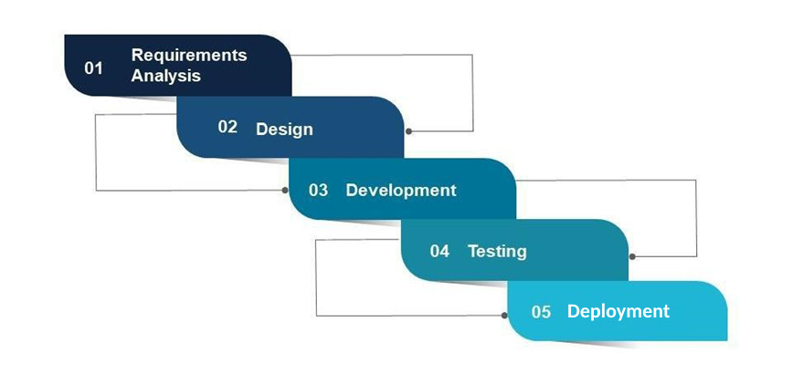

**Figure 1.1: Waterfall Methodology**

**Requirements Analysis**: At this stage, gathering detailed information about what this project requires. This information can be gathered in a variety of ways, including interviews, questionnaires, as well as interactive brainstorming.

**Design**: Creating the system based on the requirements that have been established. During this phase, no coding takes place, but the team establishes specifications such as programming language or hardware requirements.

**Development**: During this stage, coding takes place. Programmers take the information from the previous stage and turn it into a working product. They typically write code in small pieces that are integrated at the end of one phase or the beginning of the next.

**Testing**: Once all coding is done, testing of the product can begin. Testers find and report any problems in a systematic manner. If serious issues arise, the project may need to return to phase one for reevaluation.

**Deployment**: After the testing phase, this involves the actual release and installation of the software system for use by end-users. The product was delivered to the client and is currently in use. Again, major issues may force a return to phase one.

Following are the reason behind using Waterfall Model as the development methodology:

* In this model, processes and results are well documented, clear and fixed.
* Technology and tools used are not dynamic and is stable. Requirement is clear.
* Easy to arrange tasks.
* Before the next phase of development, each phase must be completed.

## 1.6 Report Organization

**Introduction**

This chapter deals with the introduction of the system with its objectives and limitations along with the reason why the system is made.

**Background Study and Literature Review**

This chapter defines and describes Background Study and Overview of related existing systems.

**System Analysis and Design**

This chapter focuses on the different requirement of the system, which describes about the functional, non-functional, feasibility analysis, Data Modeling (ER-Diagram), Process Modeling (DFD), Architectural Design, Database Schema Design and so on.

**Implementation and Testing**

This chapter focuses on the tools used in system development, implementation specifics, and test results.

**Conclusion and Future Recommendation**

This chapter presents a concise summary of the project's results, lessons learned, and conclusion. It also explains what has been done and potential future improvements.

Top of Form

# CHAPTER 2 :

# BACKGROUND STUDY AND LITERATURE REVIEW

## 2.1 Background Study

The current system employed in the Futsal Court relies solely on a manual process, which poses several limitations for both staff and customers. The existing method involves recording all booking data in a logbook, requiring users to either call or physically visit the Futsal Court to check court availability. This process not only consumes time but also lacks convenience for customers, who have to personally verify court availability.

Once users confirm court availability, staff members manually check the logbook to retrieve recorded booking data. If the desired court is available at the requested time, customers proceed with the booking process. The staff then updates the logbook to reflect the new booking information. However, in cases where the court is already booked, the booking process is automatically terminated. This manual system presents several challenges. Firstly, it is time-consuming for both staff and customers, as they need to physically interact and perform multiple manual tasks. Additionally, relying on a logbook increases the risk of errors, such as double bookings or incorrect data entry. This can lead to conflicts and customer dissatisfaction. Furthermore, customers may face disappointment when they visit the Futsal Court only to find that the court they wanted is already booked, resulting in wasted time and inconvenience. To address these limitations, the implementation of an automated system like the proposed Futsal Management System can bring numerous benefits. By digitizing the booking process, customers can easily access real-time court availability through a user-friendly web application. This eliminates the need for physical visits or phone calls, providing greater convenience and saving time for both customers and staff.

Furthermore, the system can provide comprehensive reporting and analytics features, allowing staff members to analyze booking patterns, peak hours, and customer preferences. This data-driven approach enables the Futsal Court to optimize their operations, allocate resources efficiently, and make informed business decisions.

## 2.2 Literature Review

Futsal is a rapidly growing sport around the world, and its popularity has led to an increase in the number of futsal facilities. As a result, the need for efficient futsal management systems has also increased. Several studies have focused on the development and implementation of futsal management systems to improve operational efficiency, customer satisfaction, and financial performance.

[**hamrofutsal**](https://www.hamrofutsal.com)

hamrofutsal is a domestic online website for booking a futsal. The website was informative was easy to navigate and use. But it is not working properly at the moment as it is on trial phase. It can show futsal from different cities but right now it is not working. This was not so nice experience to use the website. [2]

**Playo**

Playo is a comprehensive sport booking platform that allows users to find and book various sports facilities, including futsal courts. It operates in multiple cities and provides information about court availability, pricing, and amenities. Playo also offers features like online payment options, reviews and ratings of the facilities, and the ability to connect with other players for matches or events. [3]

**BookMySports**

BookMySports is an online platform dedicated to sports bookings, and it includes futsal court reservations. The website provides a user-friendly interface where you can search for available futsal courts in different cities. You can view detailed information about the facilities, such as court specifications, pricing, and user reviews. BookMySports also allows you to make online payments and manage your bookings through their platform. [4]

**Khel Now**

Khel Now is a sports platform that covers various aspects of sports, including futsal court bookings. They have a dedicated section on their website where you can search for available futsal courts in specific regions. Khel Now provides comprehensive information about the facilities, including pricing, court dimensions, and user ratings. They also offer directions to the venues and the option to make online reservations. [5]

**Just Play Sports**

Just Play Sports is an online platform that focuses on sports bookings and event organization. They offer the convenience of booking futsal courts through their website or mobile app. Just Play Sports provides real-time court availability, allowing you to check and book available slots. The platform also features online payment options, user reviews, and the ability to organize events or tournaments. [6]

**Sportsgram**

Sportsgram is an online sport booking platform that covers various sports facilities, including futsal courts. Although Sportsgram operates in specific regions, it provides a user-friendly interface for finding and booking available futsal courts. You can browse through the available options, view pricing details, and make bookings through their website or mobile app. [7]

A futsal management system using the internet of things (IoT) technology. The system allowed customers to book futsal courts online, while facility administrators could manage court availability, league scheduling, team registration, and financial tracking. The authors found that the system improved operational efficiency and customer satisfaction and reduced energy consumption. [8]

FMS using the cloud computing platform. The system allowed customers to book futsal courts online and track their booking histories, while facility administrators could manage court availability, league scheduling, and financial tracking. The authors found that the system reduced administrative workload, increased customer engagement, and improved data security. [9]

A web-based futsal management system for a futsal facility in Portugal. The system allowed customers to book futsal courts online, while facility administrators could manage court availability, league scheduling, team registration, and financial tracking. The authors found that the system improved operational efficiency, increased customer satisfaction, and generated additional revenue for the facility. [10]

In conclusion, the literature suggests that futsal management systems can improve operational efficiency, customer satisfaction, and financial performance. The studies highlighted the importance of user-friendly interfaces, efficient database design, secure data storage, and data analytics for futsal management systems. Further research is needed to investigate the long-term impacts of futsal management systems and their potential to drive innovation in the sports industry.

# CHAPTER 3 :

# SYSTEM ANALYSIS AND DESIGN

## 3.1 System Analysis

### 3.1.1 Requirement Analysis

To establish clear understanding of what the system should do, how it should behave, and what constraints or limitations it should face, there are several analyses performed. The functional and non-functional requirements of the application are given below:

**Functional requirements**

Functional requirements are the features that the developing system must have. The functional requirement of that we identified are:

**For Admin**

* The system should allow admin to login and logout of the system
* The system should allow admin manage the customers and futsal owners.
* The system should have feature to allow admin to manage contact us query.

**For Customers**

* The system should be able to login/signup users in the system.
* The system should allow user to explore the various futsal.
* The system should allow user to view the reservation.
* The system should allow user to edit their profile information.
* The system should allow user to communicate with futsal.
* The system should allow user to change their password.

**For Futsal Owner**

* The system should allow user to add their Futsal information.
* The system should allow user to edit and delete the information.
* The system should allow user to change their password.
* The system should allow user to monitor payment status.
* The system should allow user to view details of the person booking the futsal.

**Use case diagram**

In the Futsal Management System, there are three main actors: Admin, Customer, and Futsal Owner. Admin is responsible for managing the system, the Customer interacts with the application to browse and book futsal courts, and the Futsal Owner manages their futsal court listings.

The admin has several processes available to them. They can log into the system to access administrative features and log out when finished. Admin can manage customers, including creating, reading, updating, and deleting customer profiles. They can also manage futsal owners, handling tasks such as creating and editing owner profiles. Admin is responsible for managing contact queries, which involves viewing and responding to queries received from customers and futsal owners.

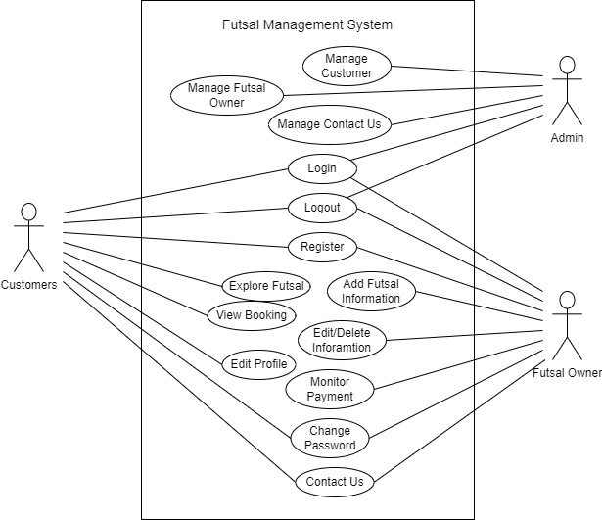

**Figure 3.1: Use case diagram of FMS**

The Customer interacts with the application to browse and book futsal courts. They can register and log into their accounts, explore various futsal options, make reservations for desired courts, view reservation details, communicate with futsal owners, edit their profile information, and change their passwords.

The Futsal Owner has functionalities related to managing their futsal court listings. They can add futsal information, edit and delete existing information, change their password, monitor payment status, and view details of customers who have booked their futsal courts.

The use case diagram illustrates the interactions and functionalities of the Futsal Management System, highlighting the actions that the Admin, Customer, and Futsal Owner can perform within the system. It provides a clear overview of the system's capabilities and the roles played by different actors in the futsal management process.

**Non –functional requirements**

Non-functional requirements make the functioning of the system easier and effective. The non–functional requirements of this project are:

* **Performance**

The web-application is simple, small-scale project, which can work effectively on limited hardware capability. Load time is reduced to increase the performance.

* **Availability**

Users can access to the services of the application on time every time. Likewise, the system can run on multiple browsers like chrome, Firefox, Microsoft edge, etc.

* **Security**

The user using the services of the system is protected against unauthorized accessing as each user have e-mail and password to authenticate them. The password is also protected by spring security.

* **Usability**

The application is also very easy to understand and use. The service navigation is providing smooth informative and interactive.

### 3.1.2 Feasibility Analysis

The feasibility study concluded that the project is able to be implemented successfully as it was carefully planned.

1. **Technical Feasibility Study**

This project is entirely a web-based system. The following are the primary tools and technologies that has been utilized in this system to make this project more feasible:

**Table 3.1: Technical Feasibility Study of FMS**

|  |  |  |
| --- | --- | --- |
| Technological Knowledge | Hardware Requirements | Software Requirements |
| HTML | Laptop | MS Office |
| CSS | Keyboard | Intellij |
| React | Mouse | Postman |
| Java |  | Photoshop |
| Spring Framework |  | Browsers |
| MySQL |  | Lucid chart |
| Bootstrap |  | Project Libre |
|  |  | Visual Studio |
|  |  | Figma |

Most of the technologies used are freely available and technical skills are manageable so this project is technically feasibility.

1. **Operational Feasibility Study**

As there is no proper marketplace for FMS, establishing and hosting this web application provide a suitable platform for both futsal owners and customers. This system is fully functional, able to be successfully deployed, and feel simple to use while booking the futsal because it is very user-friendly. It incorporates all requirements utilized for futsal management systems.

1. **Economic Feasibility Study**

This FMS project is an academic project so that most of the software’s would be manageable. We only be needing a laptop and a working internet connection to run the application. As a result, no economic feasibility assessment are required.

### 3.1.3 Data Modeling (ER-Diagram)

This ER (Entity Relationship) diagram represent the model of this project. It represents all the entity involved in the system and their relation among one another. There are four major entities names Admin, Customer, Futsal and Payment. Each entity has their own attributes representing the properties of the entity.

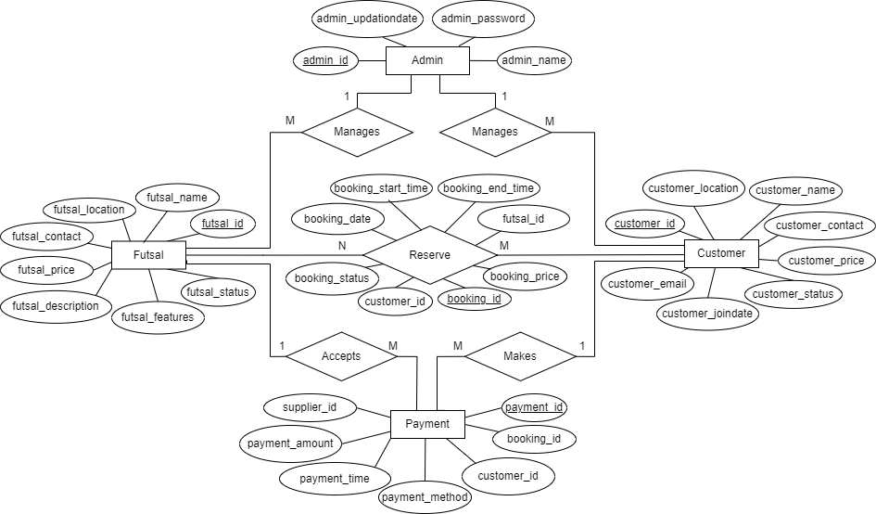

**Figure 3.2: ER-Diagram of FMS**

Customers can explore various futsal’s located in different locations where they can see their description, price, features and many more. And they can book the futsal at the available and suitable time where they all can play. When they book the futsal there are various methods for payment, a customer can choose anyone method and do the online transaction so that even if the customer doesn’t come, futsal owner should not get loss at their business.

In the above figure there are four entities they are Futsal, Customer, Payment and Admin. Here, each entity has their own attributes and attribute like id are set as primary key to make it unique. All Entities are connected through different relationships having their own specific works to perform. Here customer books a futsal and makes payment, futsal can accept/monitor the payment and they are booked by the customers whereas admin can manage both customers and futsal.

### 3.1.4 Process modelling (DFD)

Data Flow Diagram (DFD) shows the flow of data from external entities into the system, and from one process to another within the system. It is a tool used in software engineering to model, analyze, and design information systems. Following diagram is context diagram which is used for representing the flow of data in the FMS.

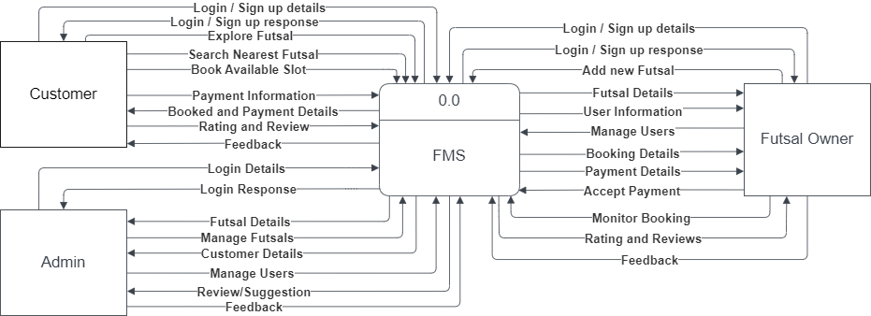

**Figure 3.3: Context Diagram of FMS**

In the above context diagram, we can see the overview of the whole system. Data to the system comes from three entity: admin, customer and futsal owner. Admin can login, manage the reviews, users and futsal. Users can login/signup, view futsal, booking, make and do payment actions, give rating to the futsal and can send reviews. Futsal owner can login/signup, add their futsal, give feedback, accept payments through different methods and can make their futsal available for booking.

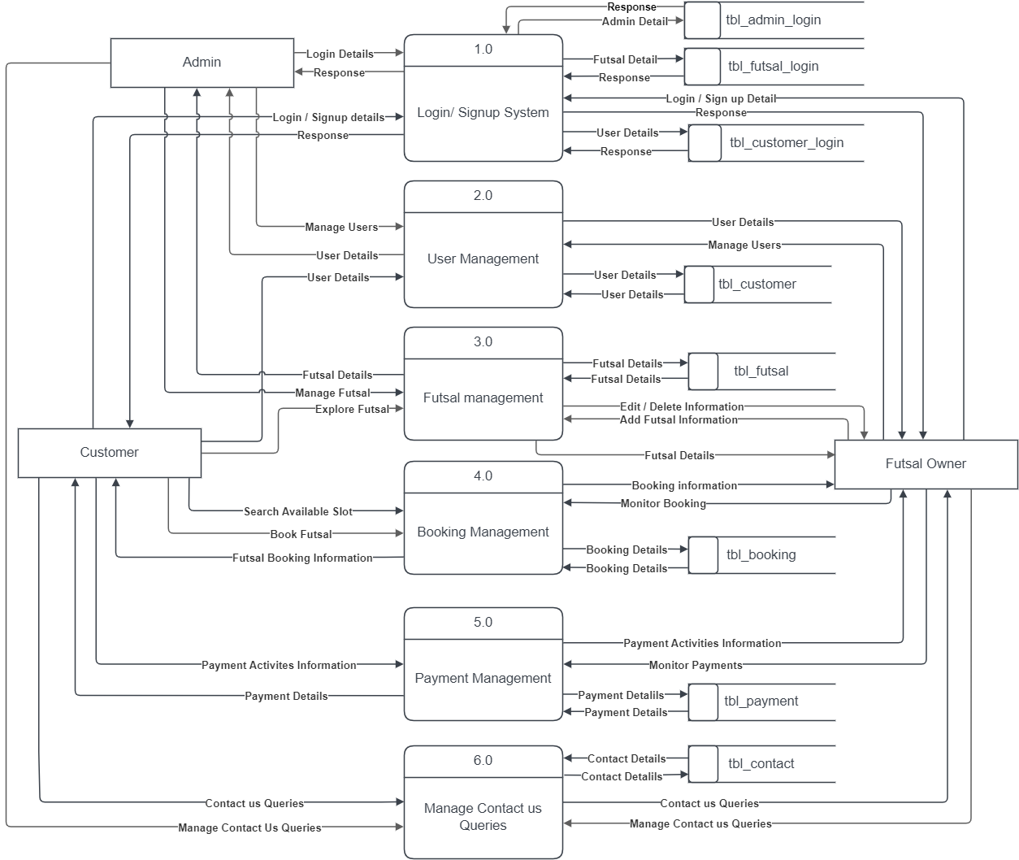

**Figure 3.4: Level 1 DFD of FMS**

In the above level 1 diagram, we can see the further breakdown of the system, there are six process, login/signup process, user management, futsal management, booking management, payment management and manage contact us queries. The data flow through these processes to perform all the functionalities of the application. To flow data through each process, tables in db are created where all the data are stored and retrieved whenever it is needed. The login/signup system, is responsible for user authentication and registration. The user management has all the data of customer so that they don’t have to put their details again and again for booking. Likewise, futsal management has also data of futsal so that any customer can explore them without any problems. The payment management is responsible for all type of transaction which performed under this system. At last, contact us system contains data which are sent by customers so that futsal and admin can feedback them for better interactive of the system.

## 3.2. System Design

To realize the different functional requirement of the system in graphical form, different design diagram of the system has been prepared which are as follows:

### 3.2.1. Architectural Design

The proposed system follows a 3-Tier web-based architectural design, utilizing a Client/Server Architecture. This architectural approach ensures the separation of concerns and allows for independent development and maintenance of the user interface, functional process logic, computer data storage, and data access modules. Each tier operates on different platforms, providing flexibility and scalability to the system. The client tier focuses on delivering a user-friendly interface, the server tier handles the business logic, and the data storage tier manages data persistence. By adopting this architecture, the system can achieve modularity, scalability, and maintainability. [11]

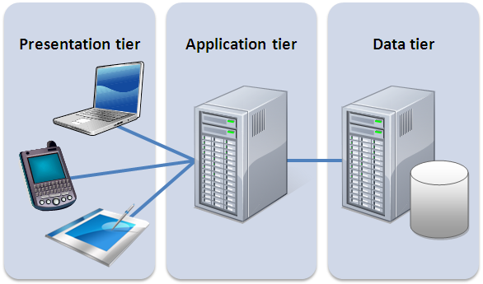

**Figure 3.5: Three Tier Architecture of FMS**

1. **Client layer:** The client layer, also known as the presentation layer, comprises the user interface component of the application. This layer facilitates communication with other layers through Application Program Interface (API) calls. It focuses on providing a user-friendly and intuitive interface for users to interact with the application.
2. **Application layer:** The application layer is responsible for implementing the business logic of the system. It handles tasks such as data validation, calculations, and data insertion. This layer serves as an intermediary between the user interface layer and the database layer, facilitating efficient communication and processing of data. By encapsulating the business logic, it promotes modularization and separation of concerns.
3. **Database layer:** The database layer is where the actual database resides. It is responsible for connecting to the database and executing operations such as data insertion, update, deletion, and retrieval based on user input. This layer ensures that data is stored and managed independently of the application layer, enabling scalability and data integrity.

The decision to adopt the three-tier architecture is driven by several factors:

* **Logical Separation**: The architecture provides a clear separation between the user interface, business logic, and database layers. This separation enhances modularity, making it easier to understand, maintain, and update each layer independently without affecting the others.
* **Ease of Maintenance**: With the clear division of responsibilities, maintaining and troubleshooting the system becomes more manageable. Changes or updates can be made to one layer without impacting the functionality of the other layers, reducing the risk of unintended consequences.
* **Scalability and Flexibility**: The three-tier architecture supports scalability by allowing each layer to scale independently based on the specific requirements. This flexibility enables the application to handle increasing user demands and accommodate future growth without affecting the overall system performance.

### 3.2.2. Database Schema Design

The figure below is the database schema design of Futsal Management System. Database schema design is used to show basic structure of the system. In this system, there are five tables in the databases each of them has their own fields where their id is primary key and if that id is used in another table, it becomes foreign key and foreign key are connected to another table with a line. There is data type of each entity and the foreign key in schema is represented by the arrow as shown in the diagram.

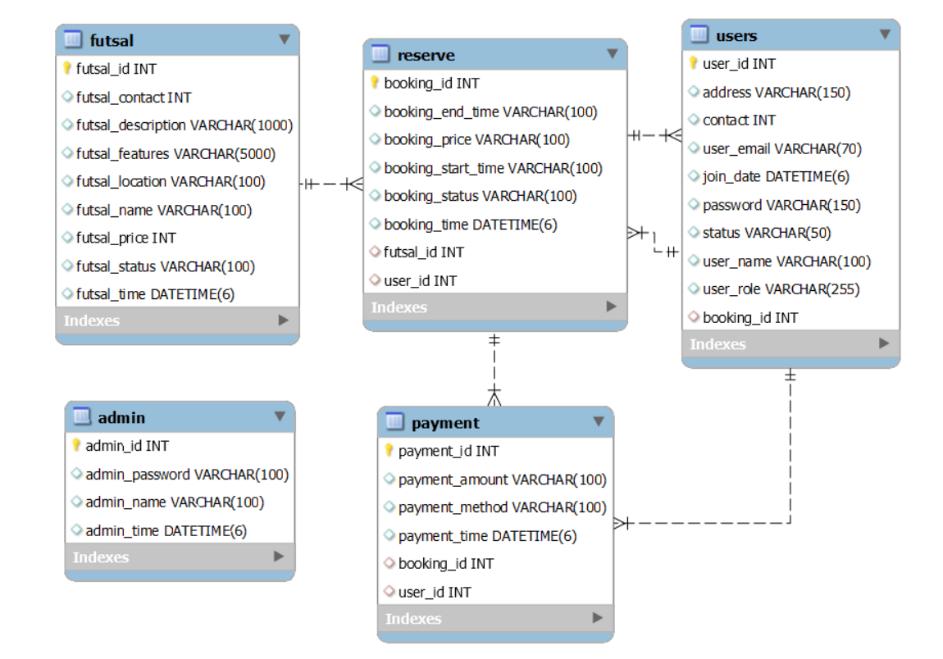

**Figure 3.6: Database Schema of FMS**

### 3.2.3. Interface Design

Interface design was made using Figma.

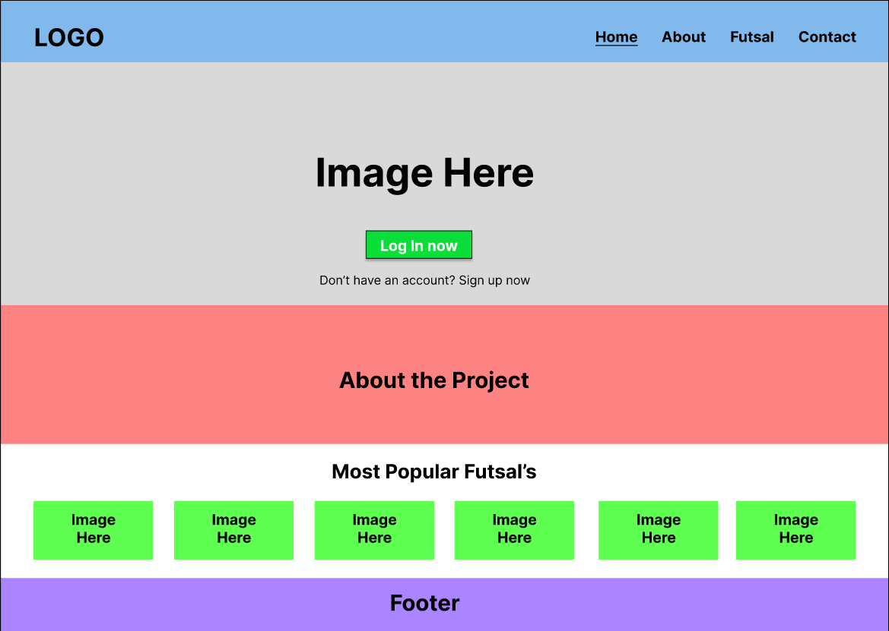

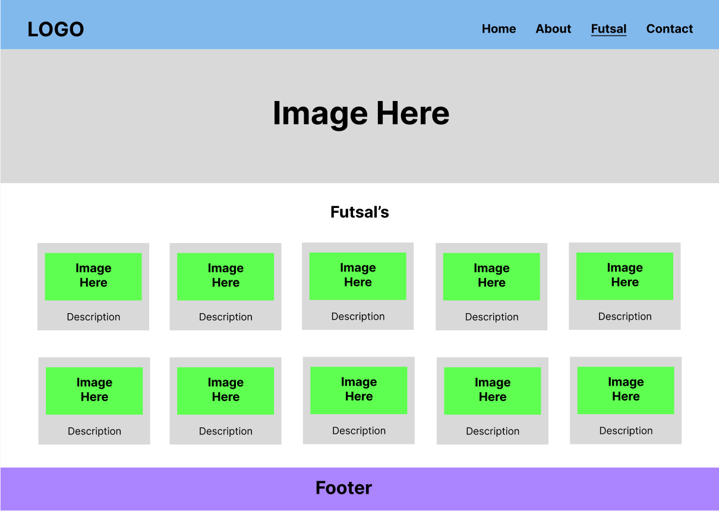 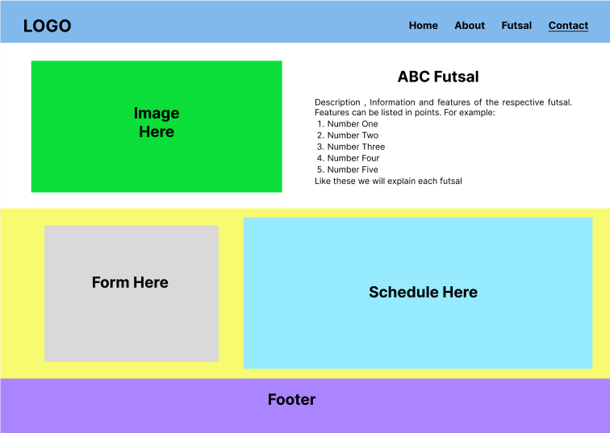

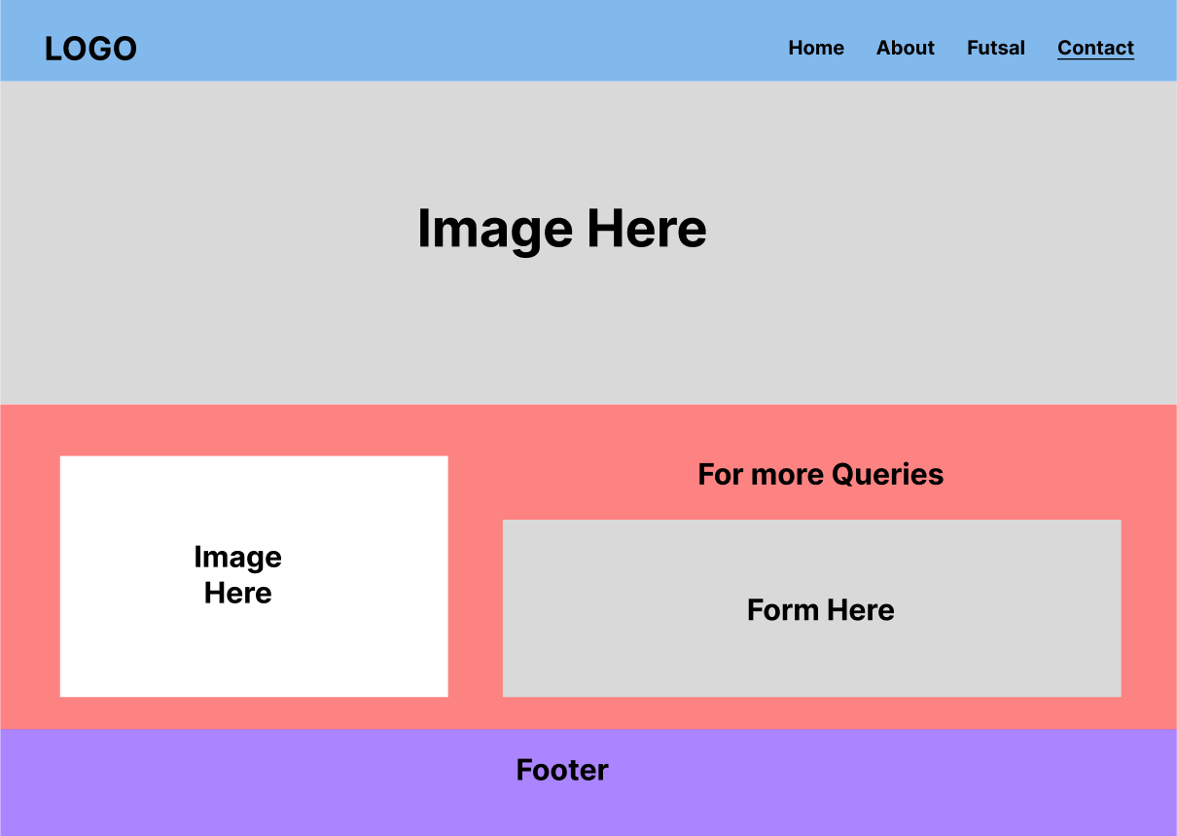

## 3.3 Algorithm

Geohashing is a way to encode a geographic location into a short string of characters, called a geohash, which can be easily shared, stored, or transmitted. Geohashing has a number of useful applications, such as location-based search, spatial indexing, and geotagging. [12]

The geohashing algorithm can be used in various projects where location-based data is needed. Here's how geohashing algorithm has been implemented in a project to know the location:

1. Collect the latitude and longitude coordinates of the location you want to encode.
2. Use the geohashing algorithm to convert the coordinates into a geohash string.
3. Store the geohash string in a database or other data storage system, along with any additional information you want to associate with the location.
4. When you want to retrieve the location, use the geohash string to look up the corresponding latitude and longitude coordinates.
5. Use the retrieved coordinates to display the location on a map or perform other location-based operations. [13]

For example, to calculate the geohash code for the location (37.775,-122.419) with precision level of 6, you would follow these steps:

1. Latitude: 37.775, Longitude: -122.419
2. Precision level: 6 (This divides the world into cells of approximately 0.61km x 0.61km)
3. Convert latitude and longitude to binary:

Latitude: 100101.10011

Longitude: -1111001.10101

1. Interleave binary digits to create single binary string: 1-1-0-0-1-1-1-1-0-1-0-1-0-0-1-1-0-0-1-0-1-1-1-0-0-1-0-1-0-1-0-1
2. Divide binary string into groups of 5 bits: 11111 00111 11010 10111 11000 10100 10101 01101 00010 11010 11101 00001 11010 10110
3. Convert each group of 5 bits into a corresponding base-32 character: wu2g5m1b8vzs
4. Concatenate base-32 characters to create final geohash code: wu2g5m

In this project, Geohashing algorithms can be used to track the location of futsal courts. This can help the customers to optimize their resources by identifying the most popular and nearest locations and booked the futsal according to it. This can help to reduce travel times and expenses, as well as optimize the scheduling of matches based on player and facility availability.

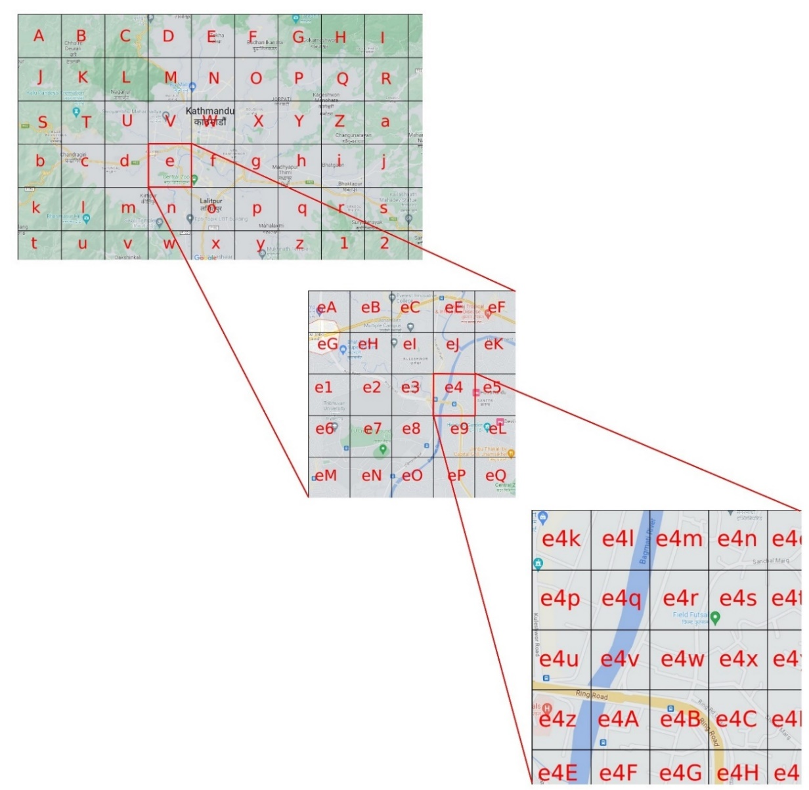

**Figure 3.7: Geo Hashing Algorithm Explanation**

In the figure above, a map of Kathmandu is shown, where cells are represented by different characters to indicate specific locations. By zooming in on a particular area, such as the cell marked with the character 'e', we can further magnify it and observe more detailed characters within it. This process can be repeated to pinpoint a specific location within the 'e4' area. The geohashing algorithm utilizes this approach to encode and store location-based data in a concise and efficient manner. By increasing the level of magnification, higher precision and accuracy can be achieved. Overall, the geohashing algorithm proves to be a valuable tool for compactly representing and managing location data.

# References

|  |  |
| --- | --- |
| [1] | "Slideteam.net," SDLC-Waterfall Model, [Online]. Available: https://www.slideteam.net/system-development-lifecycle-waterfall-model-ppt-sample. [Accessed 3 May 2023]. |
| [2] | "Hamro Futsal," [Online]. Available: https://www.hamrofutsal.com.np. [Accessed 18 March 2023]. |
| [3] | "playo," [Online]. Available: https://playo.co/. [Accessed 24 6 2023]. |
| [4] | "bookmysports," [Online]. Available: https://bookmysports.co.in/. [Accessed 24 06 2023]. |
| [5] | "khelnow," [Online]. Available: https://khelnow.com/. [Accessed 28 06 2023]. |
| [6] | "Just Play Sports," [Online]. Available: https://justplaysolutions.com/. [Accessed 28 06 2023]. |
| [7] | "Sportsgram," [Online]. Available: https://sportsgram.net/. [Accessed 28 06 2023]. |
| [8] | "Researchgate.net Review," Li et al., 2018. [Online]. Available: https://www.researchgate.net/publication/270608340_A_Systematic_Review_of_Futsal. [Accessed 28 April 2023]. |
| [9] | "Researchgate Futsal," Mohamad et al, 2020. [Online]. Available: https://www.researchgate.net/publication/Mobile_application_for_the_futsal. [Accessed 28 April 2023]. |
| [10] | "ResearchGate," Study by Pires et al, 2020. [Online]. Available: https://www.researchgate.net/publication/Mobile_application_for_the_futsal. [Accessed 1 May 2023]. |
| [11] | "Research Gate Three-tier," [Online]. Available: https://www.researchgate.net/figure/Three-tier-system-architecture_fig4_318745163.. [Accessed 30 06 2023]. |
| [12] | "Medium.com Algorithm," Geohashing Algorithm, Information, Features and uses, [Online]. Available: https://medium.com/@bkawk/geohashing-20b282fc9655. [Accessed 4 May 2023]. |
| [13] | "Geohashing.info," [Online]. Available: https://geohashing.info/. [Accessed May 2023]. |

Everest Innovative College

Solteemode, Kathmandu

Bachelor in Computer Applications (BCA)

**Project Log – Sheet**

|  |  |
| --- | --- |
| Year/Semester: 6th Sem | Project Name: Futsal Management System |

Supervisor’s Name: Basanta Chapagain

Student’s Name: Rohan Shrestha

|  |  |  |  |  |
| --- | --- | --- | --- | --- |
| **S.N.** | **Date** | **Topic/Issue Discussed** | **Comments/Next Target** | **Signature of Supervisor** |
|  |  |  |  |  |
|  |  |  |  |  |
|  |  |  |  |  |
|  |  |  |  |  |
|  |  |  |  |  |